Nardos Gebremedhin
October 26, 2025
Module 1

Java verification
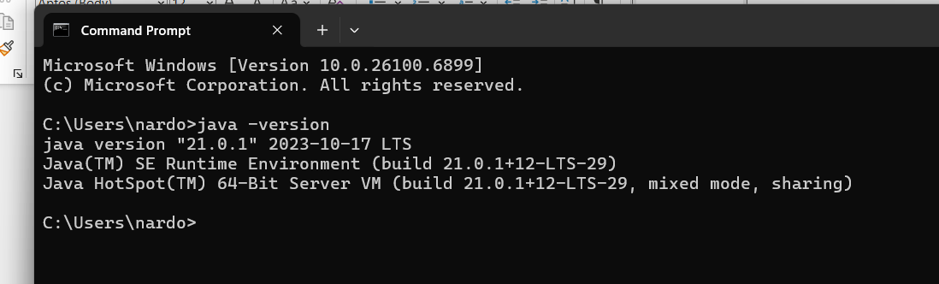

Tomcat verification
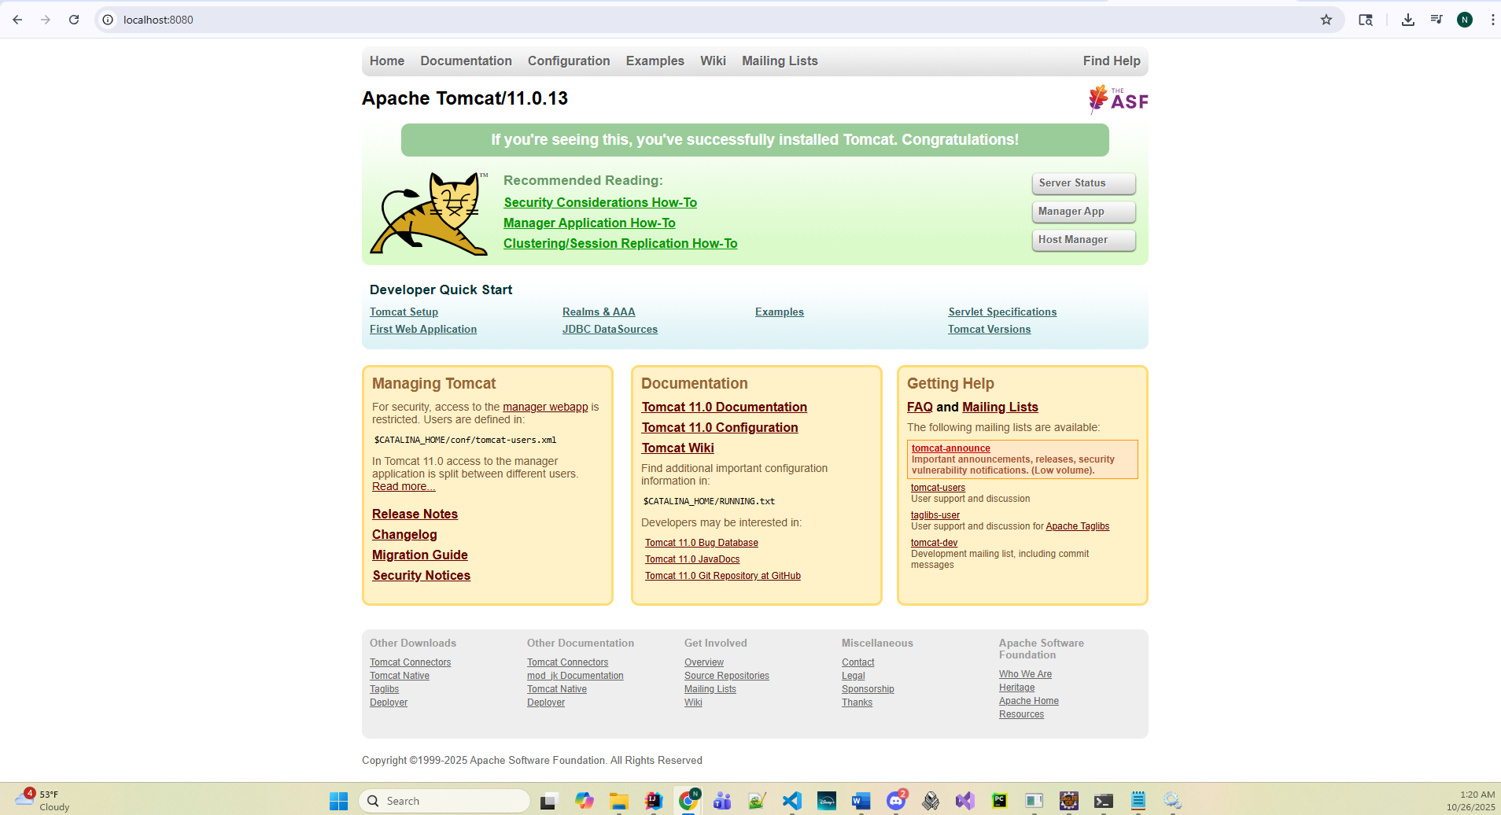

IDE(Eclipse) with tomcat verification
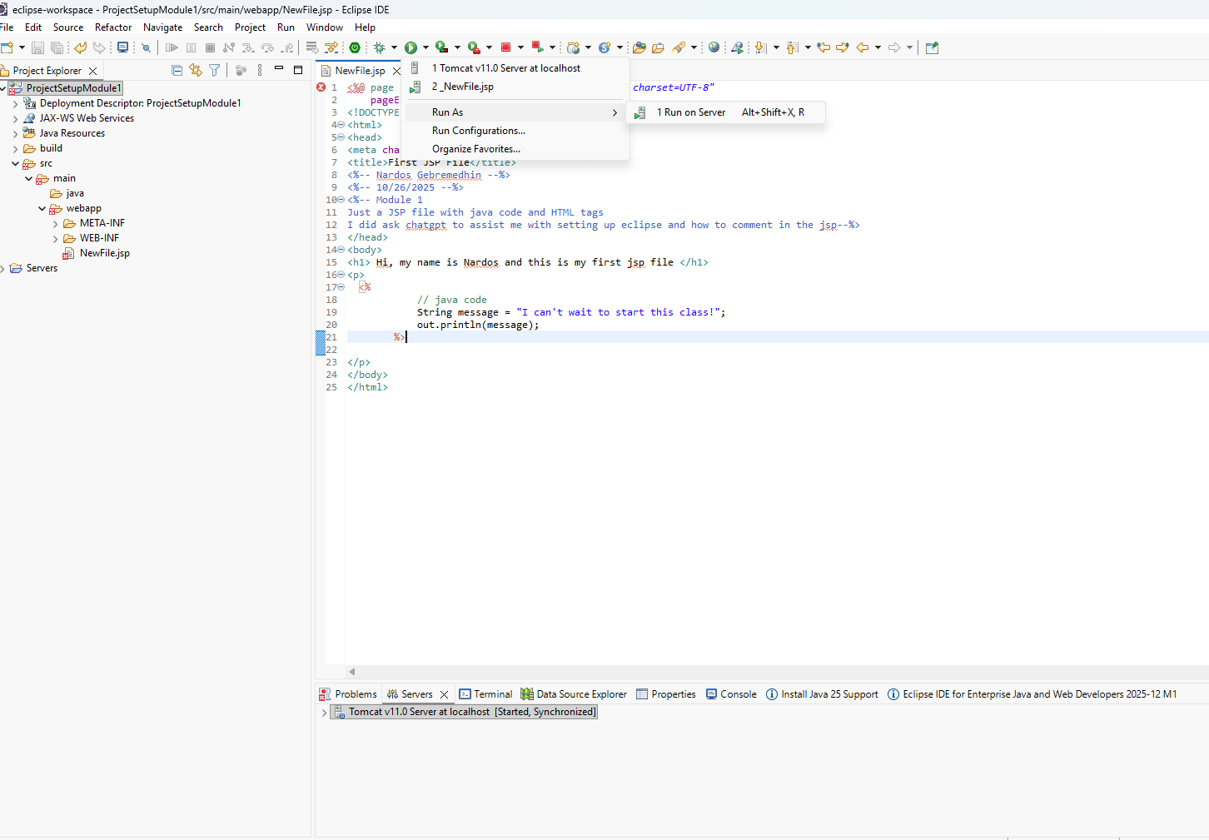

JSP verification
